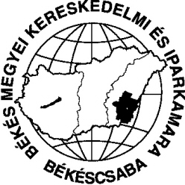 | BÉKÉS MEGYEI KERESKEDELMI ÉS IPARKAMARA  Chamber of Commerce and Industry of Békés County  Békéscsaba, Penza ltp. 5. H-5601 Pf.: 135. Tel./Fax:(36-66) 324-976, 451-775  email: bmkik@bmkik.hu web: www.bmkik.hu

A short summary of the project (Limassol, Ciprus)
The aims of our project were to study new vocational education models and methods which help people with special needs (physical disabled, mentally disabled, people with hearing or seeing problems, disgraphia or discalculia, etc.) to integrate into the education system and later to the labour market. We wanted to learn the best practices in both the theoretic and the practical part of education, and to visit those schools and institutions where these students are integrated into the school community. The life-line orientation in schools was also an important part of our study-visit. We got a very complex view of the Cipriot education system (including the legislative background of the education system) in terms of how do they focus on the students with special needs, how do they integrate them in the educational institutions, and we visited some of those schools as well. We fulfilled all the targeted aims, and got our answers to all of the questions during the five working days in Limassol.
Békéscsaba, 2014. április 25.

Szikszai Csaba
osztályvezető

